METAL BAR GRATING

AMERICAN NATIONAL STANDARD
STANIDARDMM MBG 531-24

GRA TINGS

5


ANS I/NAAM M — B-531
July 15, 2024

METAL BAR GRATING
MANUAL

NINTH EDITION

• Maximum Bearing Bar Depth . . . . 21/2 ” (63 .5 mm)

• Maximum Bearing Bar Thickness
Steel & Stainless Steel . . . . . . . . . 3/16 ” (4 .8 mm)
Aluminum . . . . . . . . . . . . . . . . . . . 1/4 ” (6 .4 mm)

• Maximum Depth of I-Bar . . . . . . . . 21/2 ” (63 .5 mm)

ANS I/NAAM M — M G 531-4

July 15, 2024


5
GRA TINGS


A Division of
derian Nati。naist

NATIONAL ASSOCIATION OF
ARCHITECTURAL METAL MANUFACTURERS

ANSI/NAAMM MBG 531-24



National Association of Architectural Metal Manufacturers
800 Roosevelt Road
Bldg. C, Suite 312
Glen Ellyn, Illinois 60137
Phone: (630) 942-6591 Fax: (630) 790-3095
www.naamm.org
Copyright © 1967, 1974, 1979, 1988, 1994 (Reprinted 1997), 2001, 2009,
2017, 2024 National Association of Architectural Metal Manufacturers
All Rights Reserved

ANSI/NAAMM MBG 531-24

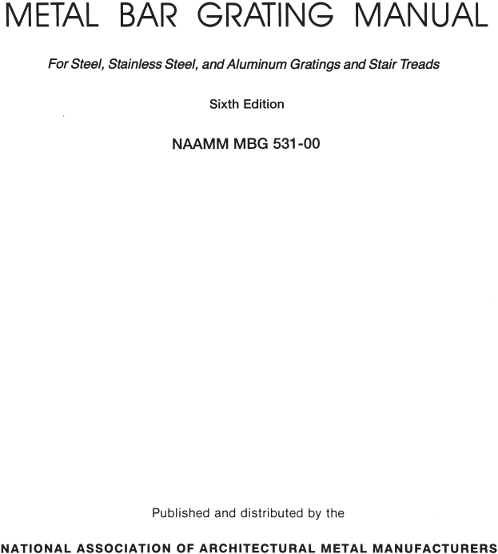


Ninth Edition

NAAMM MBG 531

800 Roosevelt Road
Bldg. C, Suite 312
Glen Ellyn, Illinois 60137
Phone: (630) 942-6591
www.naamm.org
email: info@naamm.org

NAAMMS METAL BAR GRATING DIVISION

The members of the Metal Bar Grating Division of the National Association of Architectural Metal Manufacturers have supported the preparation of this Manual. All are producers and/or suppliers of products conforming to the standards and specifications contained herein. A copy of the Membership Roster of the Metal Bar Grating Division is available from NAAMM at www.naamm.org.

ANSI/NAAMM MBG 531-24
FOREWORD
The NAAMM Metal Bar Grating Manual provides architects and engineers with current technical data on bar gratings and stair treads of steel, stainless steel, and aluminum. The information contained is based on sound engineering principles and reflects practices recommended by leading manufacturers in the industry.
The first eight editions of the manual have been widely used by the
design professions. In preparing this ninth edition, the Metal Bar Grating Division of NAAMM has reviewed its contents in detail and has made
revisions to reflect current practices.
The load tables in this edition are based on the design formulas and procedures found in ANSI/NAAMM MBG 534-14 Metal Bar Grating Engineering Design Manual, which was developed to provide a clearer understanding of the procedures used in the design of grating and treads.
Also included are metric equivalents as an aid to designers who use the metric system. The system of metric measurement used is from IEEE/ ASTM SI 10-2010, “Standard for Use of the International System of Units (SI): The Modern Metric System”.
The stair treads shown in this standard have been tested and conform to the requirements of OSHA 29CFR 1910.24(c), IBC 2012.
Changes from the previous edition, ANSI/NAAMM MBG 531-17 are indicated by the placement of a vertical line next to the changed item. It should also be noted that the Code of Standard Practice has been removed.

Standard Marking System 4
Standard Gratings 6
Minimum Sizes and Tolerances of Bars 7
Load Tables / Inch-Pound units
Steel 8
Stainless Steel 10
Aluminum 12
Load Tables / Sl units
Steel 9
Stainless Steel 11
Aluminum 13
Anchoring Details 14
Installation Notes; Panel Dimensions 15
Installation Clearances 16
Operation and Maintenance Instructions 17
Standard Tread Nosings 18
Tread Dimensions and Details 19
Manufacturing Tolerances 20
Welding Standards 21
Grating Uses 22
Information to be Provided when Ordering 23
Standard Specifications 24
Glossary of Terms 25

Bearing bar spacing is designated by a number which indicates sixteenths of an inch, or mm.
For welded or pressure-locked grating this is the distance, in sixteenths of an inch, or mm, center-to- center of bars.
For riveted grating it is the distance, in sixteenths of an inch, or mm, between bearing bar faces.

Cross bar or rivet spacing is designated by a number which indicates inches, or mm.
For welded or pressure-locked grating this is the distance, in inches, or mm, center-to-center of cross bars. For riveted grating it is the distance in inches, or mm, center-to-center of rivets, measured along a single bearing bar.

The size of bearing bars is expressed in inches of depth and thicknesses as follows:
*Equivalent bearing bar sizes in millimeters
are obtained by a multiplication factor of 25.4

TYPE

W-19-4 (1 x 3/16) steel
W-30-102 (25 x 4.8)
(25 mm x 4.8 mm)
R-18-7 (11/4 x 1/8) stainless steel
R-29-178 (32 x 3.2)
(32 mm x 3.2 mm)
P-15-2 (11/4 x 3/16) aluminum
P-24-51 (32 x 4.8)
(32 mm x 4.8 mm)
P-19-4 (11/2 I Bar) aluminum
P-30-102 (38 I Bar)
(38 mm I Bar)

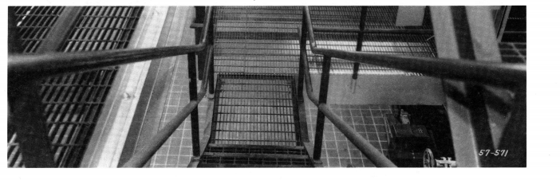

Type W-19-4 (W-30-102)

Type P-19-4 (P-30-102)

RIVETED*
Type R-18-7 (R-29-178)
Riveted grating is also available with a double crimp in the reticuline bar:

STEEL / STAINLESS STEEL WELDED*

Bearing Bars |  | Minimum Cross Bar Size
Thickness  in. (mm) | Depth  in. (mm) | Section Area  in.2 (mm2) | Weight  lb/ft (kg/m)
1/8 (3.2)  1/8 (3.2)  3/16 (4.8)  3/16 (4.8) | 3/4 (19) thru 1 (25)  11/4 (32) thru 11/2 (38) 3/4 (19) thru 11/2 (38)  13/4 (44) thru 21/2 (64) | .031 (20)  .049 (32)  .049 (32)  .062 (40) | .107 (.159)  .167 (.248)  .167 (.248)  .211 (.314)
*Minimum size shown is for cross bars on 4 inch centers. When cross bars are on 2 inch centers, the minimum size may be reduced by 25%.
STEEL / STAINLESS STEEL / ALUMINUM PRESSURE - LOCKED

Cross bars are made in a variety of solid
and hollow shapes. They can be of any
size and configuration which will provide
structural stability under the stated design loads.
STEEL / STAINLESS STEEL RIVETED

Bearing Bar Depth  in. (mm) | Minimum Size of Connecting (Reticuline) Bars
 | Thickness  in. (mm) | Depth  in. (mm)
1 (25)  11/4 (32) thru 13/4 (44) 2 (51) thru 21/2 (64) | 1/8 (3.2)  1/8 (3.2)  1/8 (3.2) | 5/8 (16)  3/4 (19)  1 (25)

Bearing Bar Depth  in. (mm) | Minimum Size of Connecting (Reticuline) Bars
 | Thickness  in. (mm) | Depth  in. (mm)
3/4 (19)  1 (25) thru 13/4 (44)  2 (51) thru 21/2 (64) | 1/8 (3.2)  1/8 (3.2)  1/8 (3.2) | 5/8 (16)  3/4 (19)  1 (25)

ALUMINUM RIVETED

NOTE: The following references were used as a guide in establishing the above bearing bar tolerances: ASTM A 1011A (1011M) Commercial Steel Type B, ASTM A 510 (A510M); ASTM B 221 (B221M), ASTM B 210 (B210M); Aluminum Association standards and data (extruded shapes) .

LOAD TABLE FOR STEEL GRATING - TYPE W-19 OR P-19

ASTM A 1011 CS TYPE B

See Appendix A for a graphic depicting table loading

F=18,000psi, E=29,000,000psi

Loads above DO NOT include the dead load of the grating .

LOAD TABLE FOR STEEL GRATING - TYPE W-19 OR P-19

ASTM A 1011 CS TYPE B F=124MPa, E=200,000MPa

See Appendix A for a graphic depicting table loading

Recommended max. span for 6.4mm deflected under uniform load of 4.8kPa

Kg/m2**

Loads above DO NOT include the dead load of the grating .

LOAD TABLE FOR STAINLESS STEEL GRATING - TYPE W-19 OR P-19

ALLOYS 304, 316 & 304L, 316L F=20,000psi, E=28,000,000psi

See Appendix A for a graphic depicting table loading

above DO NOT include the dead load of the grating .
Loads
10

LOAD TABLE FOR STAINLESS STEEL GRATING - TYPE W-19 OR P-19

ALLOYS 304, 316 & 304L, 316L F=138MPa, E=139,000MPa

See Appendix A for a graphic depicting table loading

Recommended max. span for 6.4mm deflected under uniform load of 4.8kPa

Kg/m2**

load of the grating .
Loads above DO NOT include the dead
11


LOAD TABLE FOR ALUMINUM GRATING - TYPE P-19

F=12,000psi, E=10,000,000psi

See Appendix A for a graphic depicting table loading

DO NOT include the dead load of the grating .
Loads above
12

LOAD TABLE FOR ALUMINUM GRATING - TYPE P-19

See Appendix A for a graphic depicting table loading

F=83MPa, E=69,000MPa
Recommended max. span (mm) for 6.4mm deflection under uniform load of 4.8kPa

Kg/m2**

dead load of the grating . 13
Loads above DO NOT include the

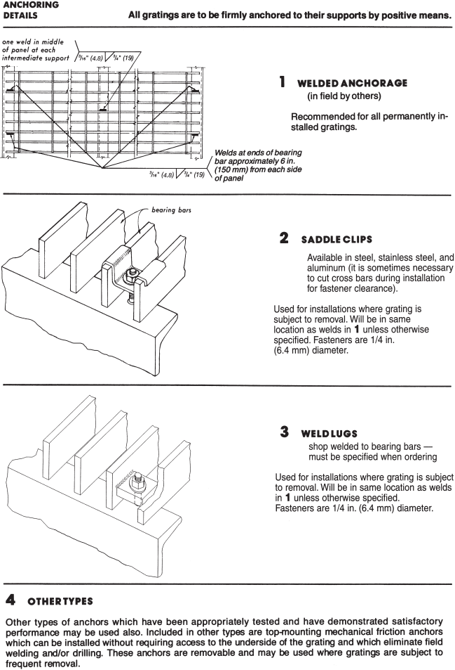

GENERAL REQUIREMENTS FOR GRATING INSTALLATION
1. Unpack grating and inspect for damage.
2. Grating shall be installed with cross bars on top.
3. Preliminarily install all grating into area per layout drawing.
4. Adjust spacing between panels to allow for proper pack out and equal spacing between panels and between supports.
5. Verify that all grating is adequately supported. Notching bearing bars at
supports or interrupting bearing bars with cutouts shall only occur when the system has been designed for such modification and is specified by the
design engineer and indicated on the plans.
6. Securely fasten all grating as specified for project or per NAAMM
recommendations.

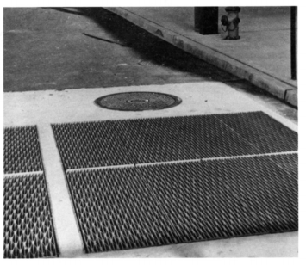

15
Shallow banding bar shall be 1/4 in. (6.4 mm) to 1/2 in. (13 mm) less than depth of grating to permit drainage.

Metal shall be used for all grating supports and provide a 1 in. (25 mm) minimum bearing surface for depths up to 21/4 in. (57 mm), and 2 in. (51 mm) minimum bearing surface for depth 21/2 in. (64 mm) and over, at each end of span.

1/4” (6) nominal
clearance between ends of cross bars on rectangular
grating or rivet heads on riveted grating.

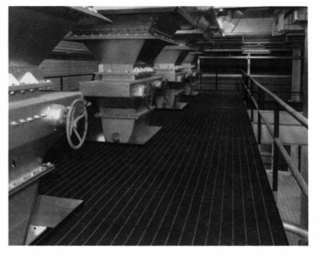

Clearances shown are recommended, but vary in accordance with dimensional tolerances shown on page 20.
Cutouts for circular obstructions are recommended to be at least 2 in. (51 mm) larger in diameter than the obstruction. It is further recommended that cutouts for all piping 4 in. (102 mm) or less in diameter be made in the field.
As shown in the drawing below, all rec- tangular cutouts are made to the next bearing bar beyond the penetration with
a clearance not to exceed bearing bar spacing.

OPERATION AND MAINTENANCE INSTRUCTIONS

1. For pedestrian load rated grating design, grating is intended for
normal walking pedestrian traffic. Precautions shall be taken to
prevent wheel or other loads beyond the design load rating for the application.
2. For other uniform or concentrated load rating applications,
precautions shall be taken to prevent loads beyond the design load rating for the application.
3. Periodically inspect grating for damage or excessive wear, such as corrosion, damage to the finish, deformation and excessive bearing bar lean beyond the tolerances as noted on page 20.
Repair or replace any areas showing damage.
4. Periodically inspect grating to be sure that all grating is securely
fastened as specified for the application or as noted on page 14, if fastening method is not specified. Replace any missing attachment hardware and tighten any loose connections.

18

carrier plate
thickness 1/8” (3 mm) minimum

DIMENSION B & C in TREAD with carrier plate detail in. (mm)

Grating  Depth | Dimension  B | Dimension  C
3/4 (19) to 11/4 (32)  11/2 (38) to 13/4 (44) | 13/4 (44)  21/4 (57) | 21/2 (63)  3 (76)
For aluminum and all treads over 13/4 (44) consult with manufacturer.

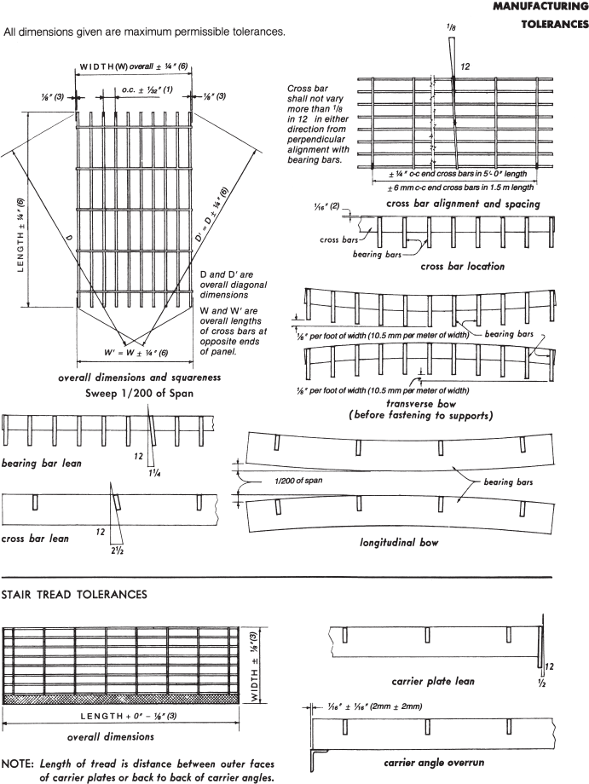


The welding standards shown here apply to those gratings and treads having
a clear opening of not less than 5⁄8 in. (16 mm) between bearing bars and those galvanized as per Specifications, page 24. See NAAMM STANDARD MBG 533 “Welding Specifications for Fabrication of Steel, Aluminum and Stainless Steel Bar Grating” for welding specifications and certification of welders.

STANDARD STAIR TREADS
( bearing bar thickness less than 1/4”(6.4mm) and bearing bar clear opening greater than or equal to 5/8” (16mm) )
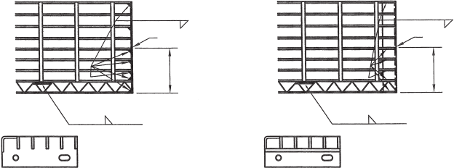
5,,
(127)
5,,
(127)
1/8”(3.2)
carrier plate

1/8”(3.2) 1” (25) at mid-span*
for stair treads
3, - 0 and greater
(914mm)
1/8”(3.2) 1” (25) at mid-span*
for stair treads
3, - 0 and greater
(914mm)
carrier angle
1/8”(3.2)

when carrier plates and carrier angles are used, the bearing bars in the front five inches,
the back bearing bar, and the nosing shall be welded to the carrier plate or carrier angle as shown.

On treads over 9-3/4 in. (248) wide weld end of center bar also.
* Treads spanning 4 ft. (1.2m) or more shall have welds located at the third points.

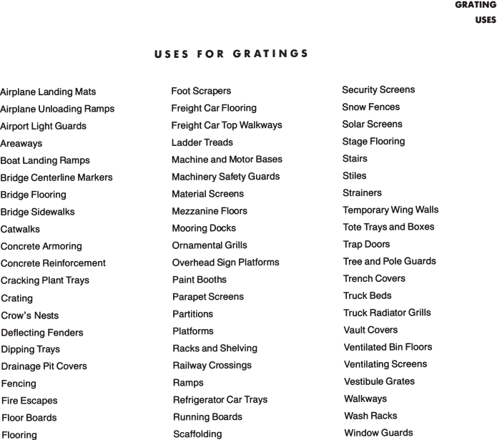
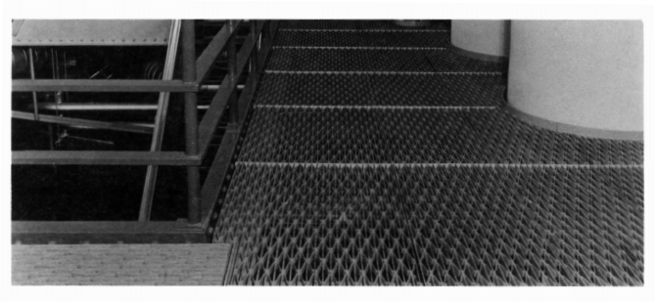

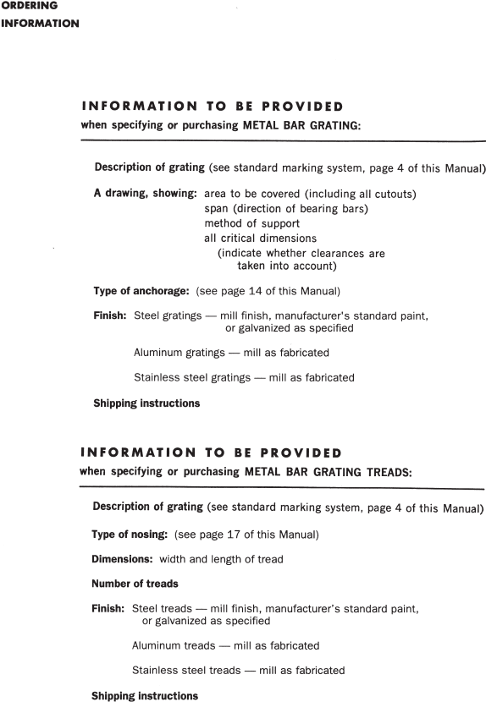
Type of nosing: (see page 18 of this Manual)

20

21

e) Finishes: Carbon steel gratings shall be specified unfinished, galvanized, or painted one coat of manufacturer’s standard paint applied in accordance with the manufacturer’s standard practice. One coat of manufacturer’s standard paint is designed as an economical solution for many applications. Gratings specified to be galvanized shall have their exposed surfaces zinc-coated by the hot dip process per ASTM A 123 after fabrication. Gratings and/or treads stored at the jobsite shall be covered or under roof.
Required covering is not the responsibility of the grating and/or tread supplier .
Unless otherwise specified, abrasive nosings will have the manufacturer’s standard finish.
Aluminum and stainless steel gratings shall have a mill (as fabricated) finish, unless otherwise specified.
III . MATERIALS
a) Steel gratings:
Steel used in bearing bars, cross bars and connecting bars of rectangular section shall have mechanical properties equal to, or greater than the performance of ASTM A 1011/A 1011M Commercial Steel (Type B) for hot rolled carbon steel sheet and strip. Cross bars made of wire rod shall conform to ASTM A 510/A 510M for carbon steel wire rods and coarse round wire, except that permissible tolerance on diameter of coarse round wire shall be ± 0.005 in. (± 0.13 mm). Combinations of these steels are permitted to be welded together.
Rivets shall be of steel prescribed in ASTM A 575, 1/4 in. (6.4 mm) minimum diameter, flat head type.
b) Aluminum gratings:
Bearing bars shall be either alloy 6005A-T61, 6061-T6, 6105-T5, or alloy 6063-T6, conforming to ASTM B 221 (B 221M). Cross bars and bent connecting bars shall be of alloy 6061 or 6063 conforming to ASTM B 221 (B 221M), or alloy 3003 conforming to ASTM B 210 (B 210M).
Rivets shall be made of aluminum wire of alloy 6053- T61 conforming to ASTM B 316/B 316M.
c) Stainless steel gratings:
Bearing bars, cross bars, and connecting bars shall
be Type 304, 304L, 316, or 316L alloy conforming to 24 ASTM A 666.

LOAD-CARRYING BAND
METRIC — The system of metric measurement used is from IEEE/ASTM SI 10-2010, “Standard for Use of the International System of Units (SI): The Modern Metric System”.

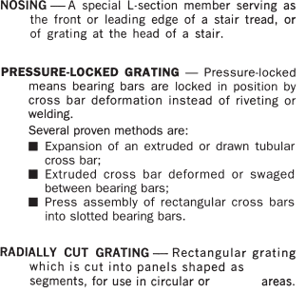
angular angular

25

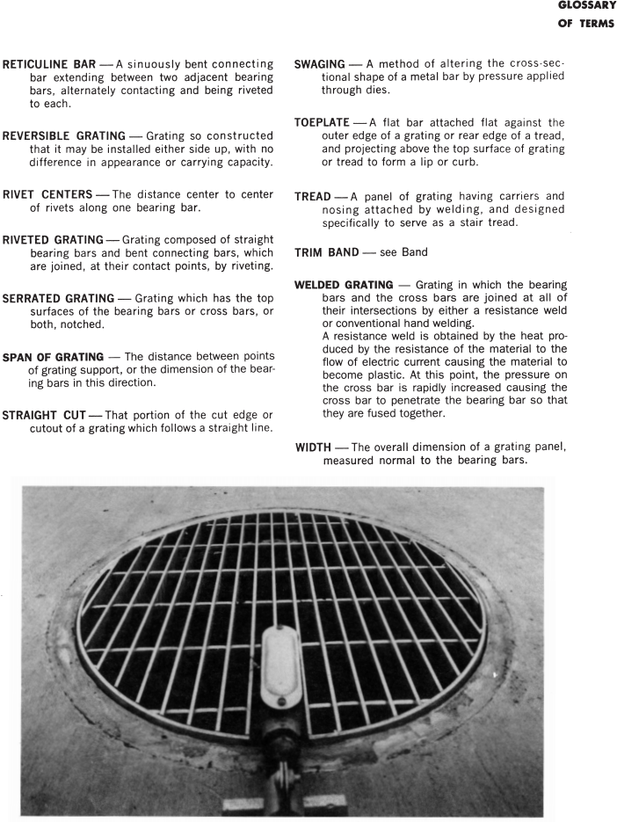
26

ANSI/NAAMM MBG 531-24

APPENDIX A
Graphic Depicting the Loadings in Tables

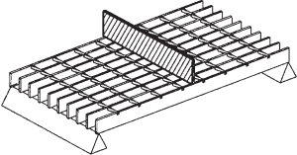

Concentrated Mid Span Load per foot of width

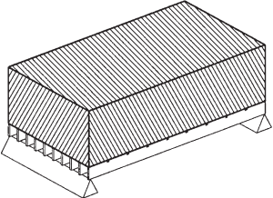
Uniform Load per square foot

27



